**­MineService**

Founder: CJ Miller

Members: Jeremy Brinegar

Ishank Tandon

Max Morgan

­

**Introduction**

MineService is a Client-Server application that would help monitor and run Minecraft servers across different systems. It can be split into two different feature sets. One for dealing with physical systems, such as resource allocation, while the other dealing with people, such as support tickets. Between these two sets there will be many sub features.

For physical system features the main ones will be on control. We’ll have ways to start, stop, and restart the server and also automated versions of those. There will also be ways to upload, edit, and delete files on the server.

The people system will include both support and permissions systems. The support side will allow people to both submit and resolve issues in a centralized semi-public place. The permissions system will control who has access to what physical system features and what things they can see on the support side.

**Stakeholders**

* Backend Server Administrators
* Minecraft Server Administrators
* Minecraft players
* Physical Server

**Affinity Diagram**

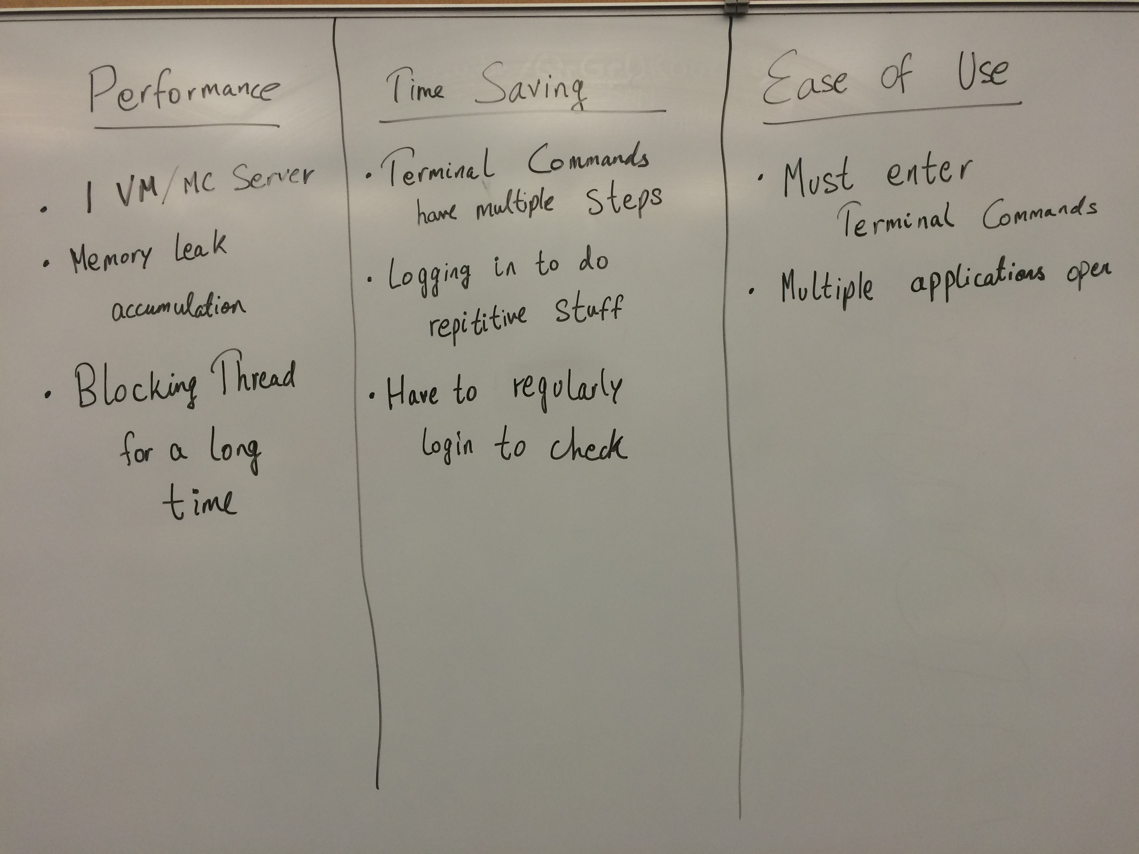

**User Stories**

* **Epic**
  + **Performance**
    - As a developer I want to give typical users better performance when running Minecraft users so that they can have a more enjoyable Minecraft experience.
  + **Time Saving**
    - As a developer I want to give typical users the ability to minimize their time spent on maintenance activities so that they can have their server up and running quicker.
  + **Ease of Use**
    - As a developer I want typical users to be able to easily accomplish their everyday tasks so that they do not have to waste time looking up fixes or syntax.
* **Feature**
  + **Performance**
    - **VM Overhead**
      * As a Server Administrator I want to reduce CPU and Memory Usage so that I can dedicate more to my clients.
      * Condition of Satisfaction:
        + Drastically reduce the number of required VMs per client.
    - **Memory Limit**
      * As a Server Administrator or Minecraft Admin I want to be notified when a Minecraft Server is approaching its memory limit so that I can see if it is an issue or just user spike
      * Condition of Satisfaction:
        + I am notified via text or email within a minute of a condition being met.
    - **Frozen Servers**
      * As a Server Administrator or Minecraft Admin I want to be notified when a Minecraft Server is frozen so that I can fix it promptly
      * Condition of Satisfaction:
        + I am notified via text or email within a minute of a condition being met.
  + **Ease of Use**
    - **Terminal**
      * I’m a person who is responsible for a couple of Minecraft servers but I don’t like to program. I prefer not having to memorize code or commands and type it in the terminal because there are so many of them. To make my life easier, I need to have a User Interface which would do all the stuff the terminal commands do with just a click of a button.
      * Condition of Satisfaction:
        + Acknowledge that I don’t have to use terminal to manage my servers
    - **Multiple Applications Open**
      * I’ve realized that the less number of applications I have open, the less CPU usage and memory leaks. Having multiple applications open can potentially slow down the servers and is also really hard to manage since I need to switch between them at the right time for the right thing. It would be so much better if I just had to have one application open which would display all the information which I seek from multiple applications and perform an action based on that.
      * Condition of satisfaction:
        + Just one User Interface which would display all the information needed
  + **Time Saving**
    - **Terminal Commands have Multiple Steps**
      * I’m an individual who owns a few Minecraft servers, however I don’t write programs as my profession. I would rather not have to enter commands into a terminal, because it takes time to memorize the commands, and if I don’t memorize the procedure of how to navigate the terminal, I will have to take time to write a document with steps outlining the commands I have to execute. It would save me time if I only had to click a button on a graphical user interface, and all of the terminal commands would be done for me.
      * Conditions of satisfaction:
        + Make sure that I don’t have to enter any commands into a terminal to manage my server.
    - **Regularly having to login to Check the Servers**
      * I’ve been told that Minecraft servers with a lot of mods on them can cause memory leaks, and memory leaks can cause a lot of memory, disk, and possibly CPU strain on my server. This can slow down all of my servers, and possibly cause them to crash. Therefore, I must log in to the windows application every three days or so to check the memory, disk, and CPU usage of each server. If a server is taking up too much hardware, I have to hope that no one is on the server, so that I can stop the server, then start it again. If there are people on the server, I either have to stop the server anyway, which will kick off all of the people who are on the server, or I have to wait until another time, log in again, and check and see if anyone is on the server. It would be much more convenient if a server automatically restarted if no players were on and the combination of CPU, memory, and disk usage reached a certain level. Also, if the server was not able to be automatically restarted, due to players being on the server, and CPU, disk, or memory usage got too high, I would like to receive a text message, e-mail, or both, describing the issue to me, so that I can manually restart the server if I saw the need.
      * Conditions of satisfaction:
        + If there are players on a server, and the combination of CPU, memory, and disk usage exceeds a certain level, notify the server owner via their specified means of contact, either text message, e-mail, or both.
        + Have the server automatically restart if the combination of CPU, memory, and disk usage exceds a certain level, and there are no players on the server.

**Storyboards**

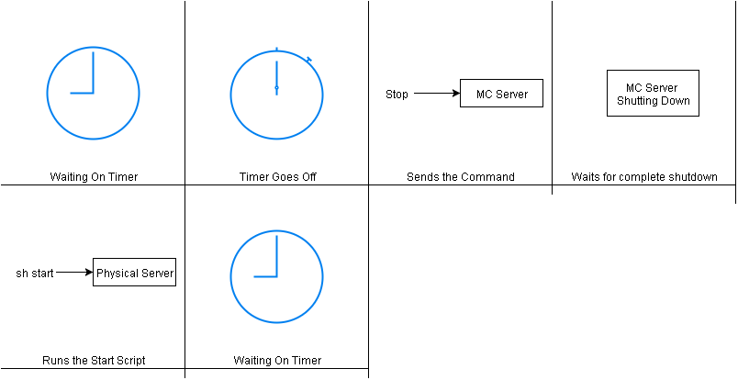

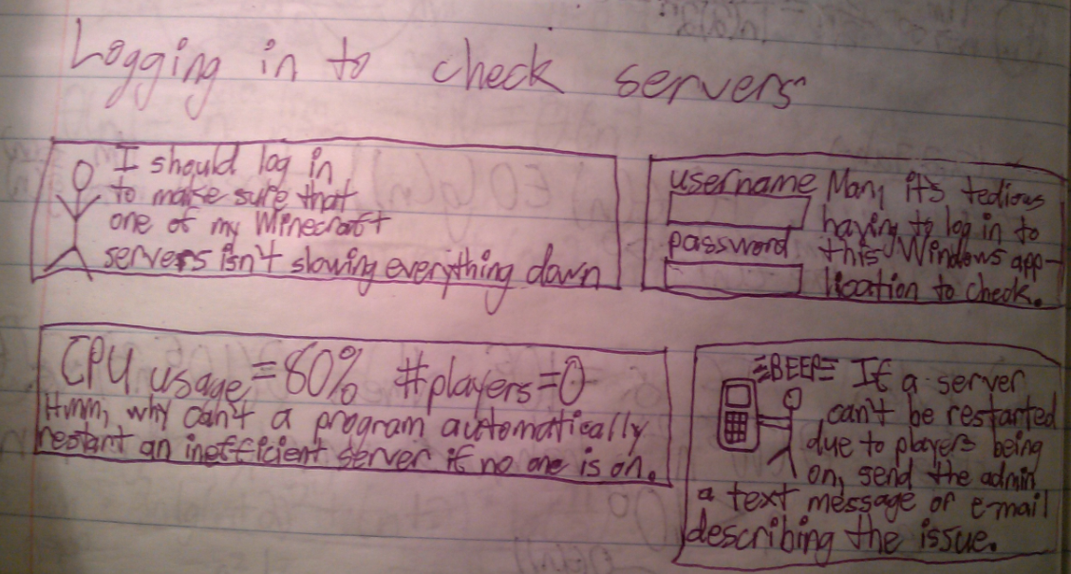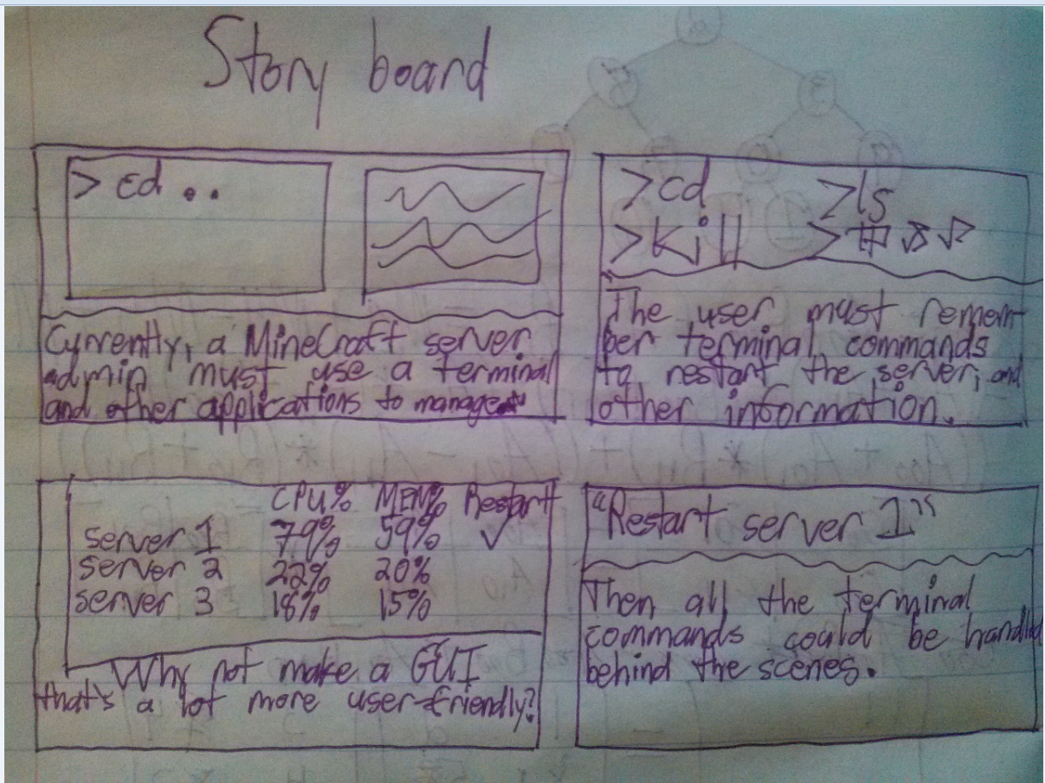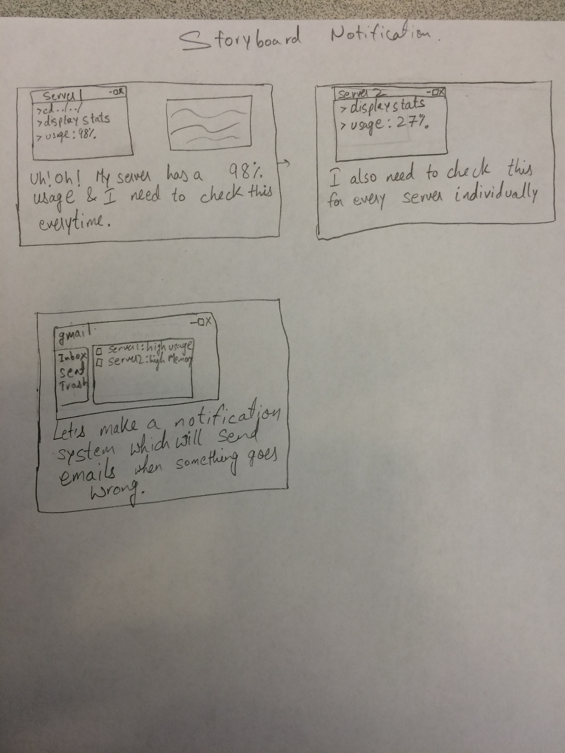

**Appendix**

* Items available upon request:
  + Interview documents
  + Usage Diagrams
  + Initial Concept Pictures and Notes
  + Notes Taken on User usage